Project Narrative for Optical Tweezer Experiment

Heterogeneous ice nucleation, the process under which liquid water freezes around a nucleation site, is still poorly understood. An analytical tool to observe this process of nucleation would allow for fundamental study of an interesting physical phenomenon and yield various practical applications, especially in areas like cloud seeding and atmospheric science. With our experiment, we aim to create this analytical tool.

To accomplish this task, we propose studying the motion of a trapped glass microsphere, which will act as the nucleation site. It is well-known that at short enough time scales, a Brownian particle behaves ballistically.[1] More interestingly, it has also been shown that even a “macroscopic” particle (i.e. diameter on the order of a few microns) trapped in an optical tweezer acts like a Brownian particle.[2] Therefore, it obeys the equipartition theorem and its velocity in any dimension follows the Maxwell-Boltzmann distribution[3]:

So, if we observe the instantaneous velocities of an optically-trapped particle in thermal equilibrium with an environment at a known temperature, we can fit the measured distribution to its theoretical counterpart and extract the mass of the particle. This will allow us to monitor the rate of ice formation; however, an important question remains: how short of a time scale can we push to before losing precision in our fitting? Our goal, of course, is to make as quick and precise of a mass measurement as possible, and so we must first characterize the performance of our system at various time scales.

We utilize a counter-propagating dual-beam optical tweezer to make our trap. Two orthogonally-polarized NIR (1064nm) beams, aligned with a 5um-diameter pinhole at the focus of the tweezer, are used for trapping. An 80MHz AOM shifts the frequency of one beam to prevent a standing wave from forming in the trap. A weak red (632nm) laser is used for illumination, and a CCD camera monitors the red light scattered by the trapped bead. Its image is displayed on a television monitor to ensure that we are trapping a single microsphere. One of the trapping beams is split by a sharp D-shaped mirror after passing through the trap, and is then incident on a balanced photodetector, which measures the displacements of the bead in a single dimension (in our case, displacements in the x-direction, or horizontally perpendicular to the beam).

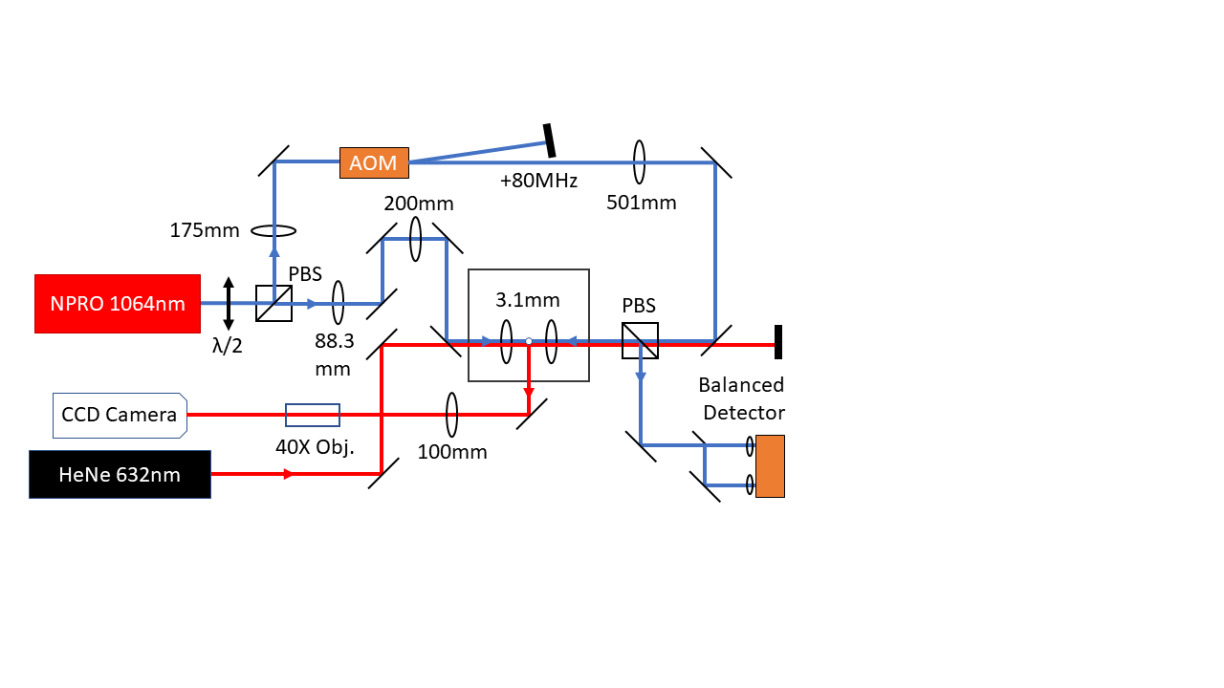

Dry silica microspheres are applied to a glass coverslip with a Q-tip and are subsequently launched from an ultrasonic piezoelectric shaker into the tweezer. The mono-dispersed spheres on the coverslip after ultrasonic vibration are shown below under a microscope.

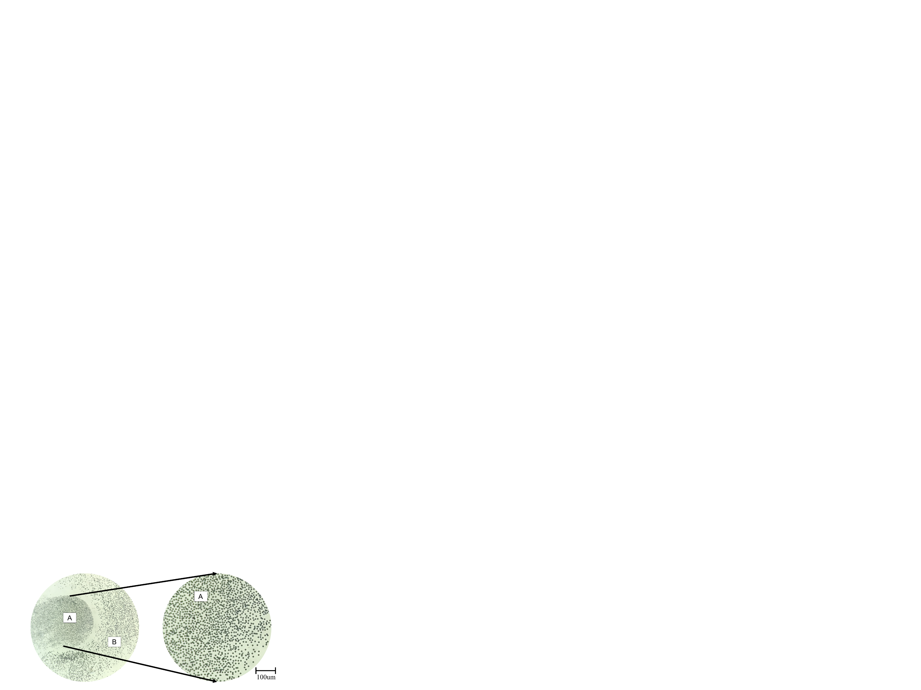

A fine plume of microspheres falls through the gap between the trapping lenses, and within a few minutes a single bead is reliably trapped. A 6.1um-diameter sphere is shown below.

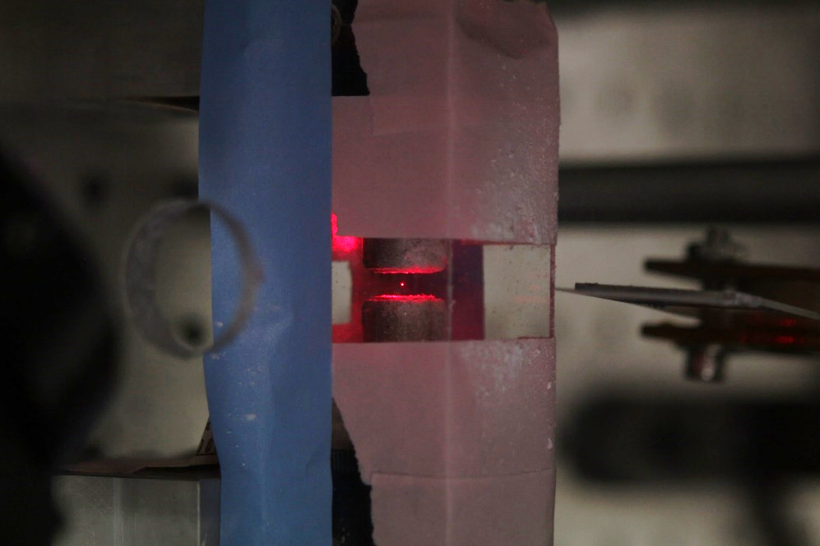

A calibration factor α, found by optimizing curve fits to known masses, coverts the voltage data from the balanced photodetector into positional data. Then, to increase the signal to noise ratio, we average several positional values before obtaining instantaneous velocities and plotting their distribution against the model. As we sample at 10MHz, an averaging time of 5us corresponds to 50 points included in the average. The effect of this averaging on velocity-time plots is shown below.

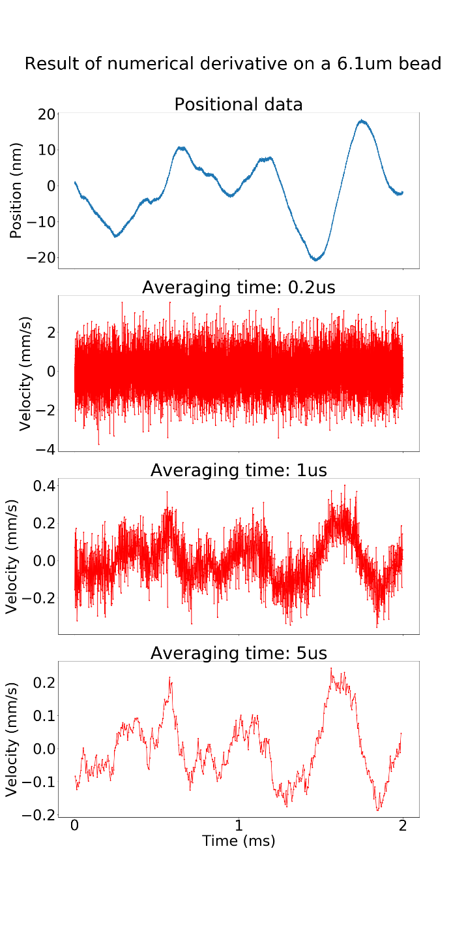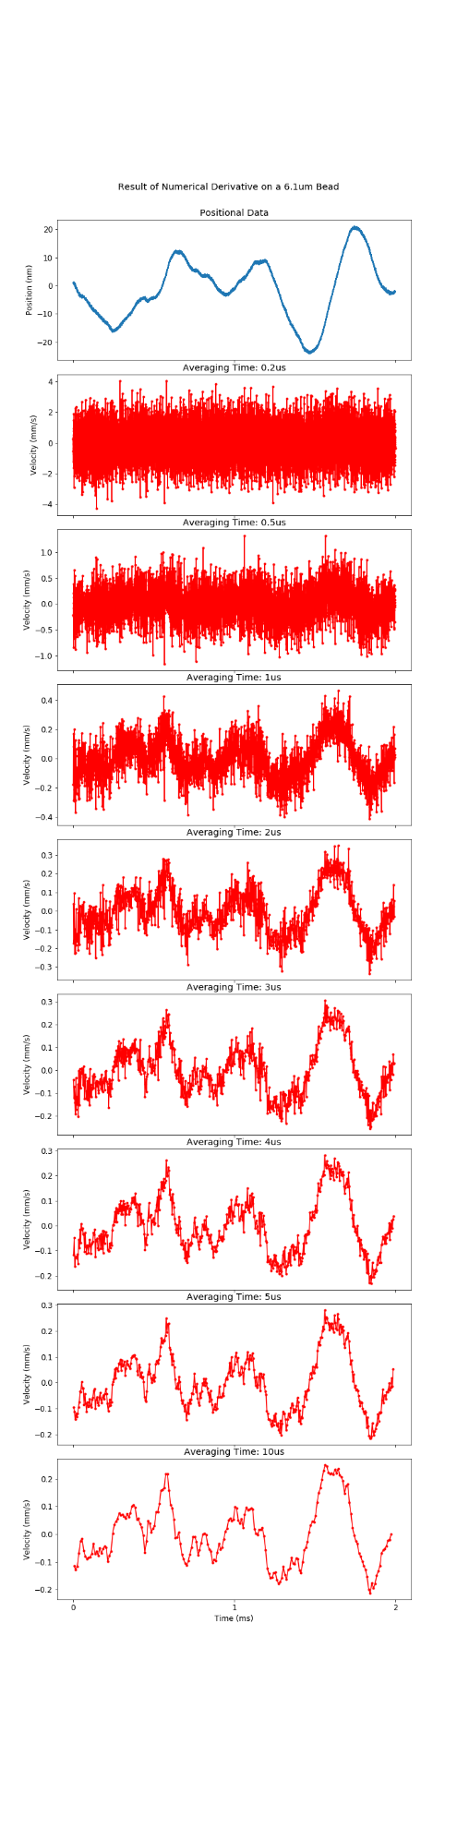

The bin size for our histograms is chosen to match the rms magnitude of the noise.[4] As the root-mean-square value of the noise is 0.09mm/s, we have 4.5Å resolution in 5us. This resolution will improve even further when noise is further reduced in the optical setup. Presently, our signal to noise ratio is approximately 24dB.

To mitigate noise in the experiment, we can Fourier transform the data to inspect the power spectra of various samples. Noise presents itself at specific frequencies which can be filtered from the Fourier transform. So, we apply an inverse Fourier transform after filtering out offensive noise peaks, which returns cleaner positional data. The effect of noise filtering is shown below.

NOISE FILTERING GRAPH

To analyze the quality of our measurement at different time scales, we take four distinct samples of the same trapped bead, whose mass does not change, and a noise sample with no bead trapped but all other parameters (e.g. laser power) kept constant. All the fittings, noise excluded, should therefore measure the same quantity, and so the precision of the system is estimated via the ratio of the standard deviation of the four measurements to the mean mass. The graph below, which includes the measured distributions as scatter plots and the curve fits as solid lines, shows a glimpse of how this precision depends on the length of the data samples.

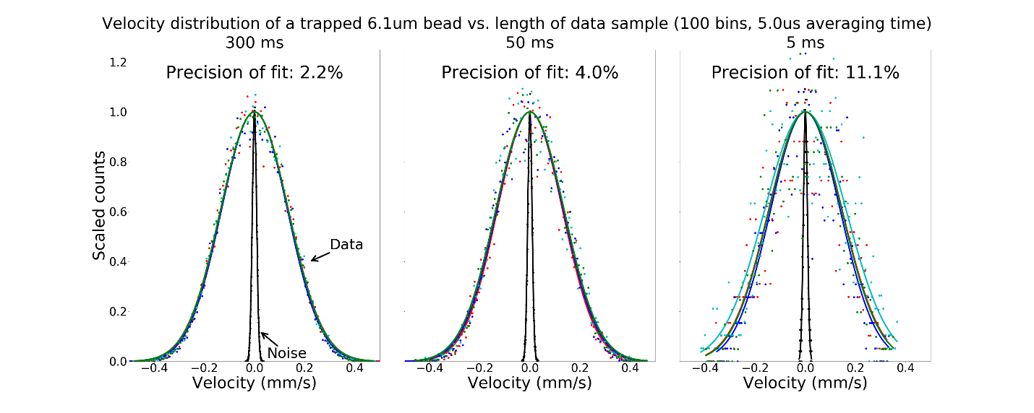

So, in the long time scale limit (i.e. hundreds of ms), we approach ~2% precision in our measurement. And, even at the scale of a few ms, we can measure the mass of the particle within about 10%. It has also been proposed to report these errors in the style of Allan variance, a tool designed to characterize the frequency drift of atomic clocks.[5] For our experiment, the error results from a combination of temperature and laser intensity fluctuations, instrumental noise and shot noise of the laser, and uncertainties in the curve fit. The Allan-style deviations of the system are shown as error bars in the upper plot below and as the dependent variable in the lower plot, with associated uncertainties included.

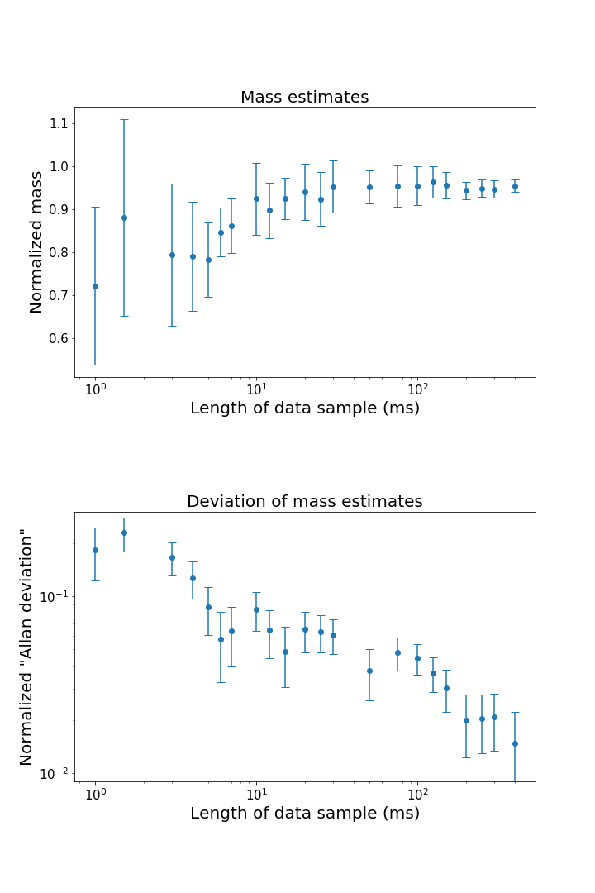

So, we can now take mass measurements in quick succession to observe a particle’s mass as it changes over time. The silica particle will act as a nucleation point, onto which we will blow cold humid air. As ice forms, we expect to observe the mass of the particle increase and will characterize the process of ice formation accordingly. We also have preliminary plans to supplement the Maxwell-Boltzmann fitting with a measurement of Mie scattering from trapped sphere to estimate the size of particle. With the combination of these two tools, we will be able to probe the process of ice nucleation extensively, even down to the monolayer.

1. T. Li et al., Measurement of the instantaneous velocity of a Brownian particle. *Science* **328**, 1673 (2010).
2. T. Li, Ph.D. thesis, University of Texas at Austin, 2011.
3. J. Mo et al., Testing the Maxwell-Boltzmann distribution using Brownian particles. *Optics Express* **23**(2), 1888 (2015).
4. S. Kheifets et al., Observation of Brownian Motion in Liquids at Short Times: Instantaneous Velocity and Memory Loss. *Science* **343**, 1493 (2014).
5. F. Czerwinski, A. Richardson, and L. Oddershede. Quantifying Noise in Optical Tweezers by Allan Variance. *Optics Express* **17**(15), 13255 (2009).